MARJELEN G. MADRIGAL CMSC 21

BS Computer Science 1

1. 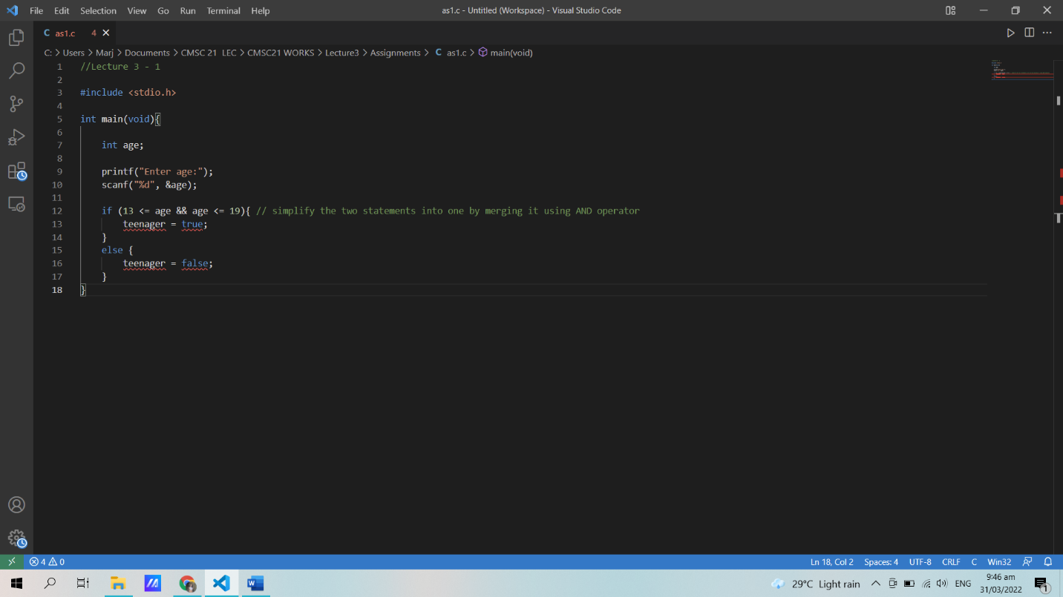
2. 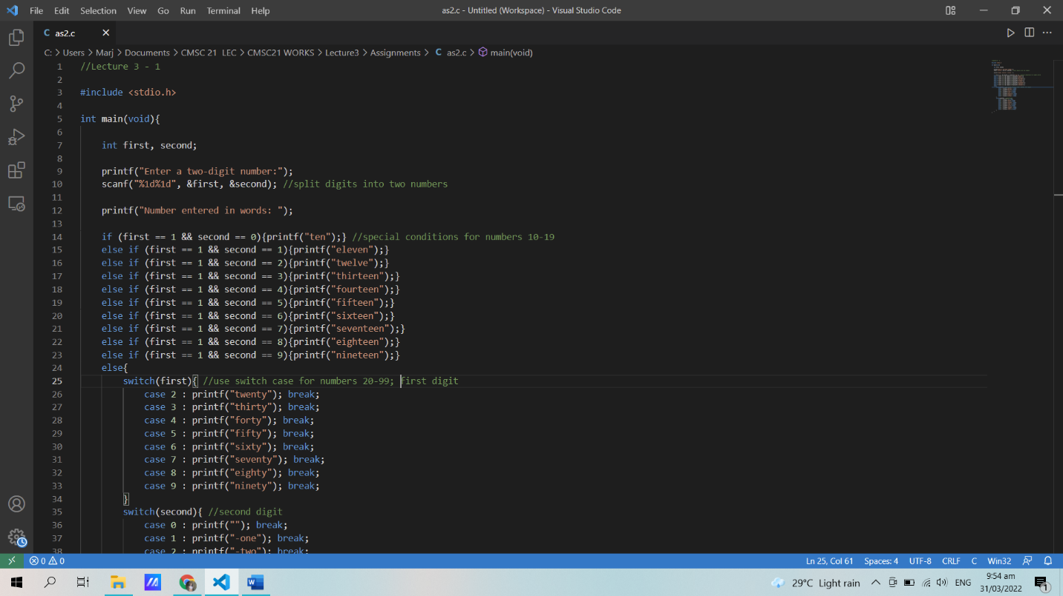

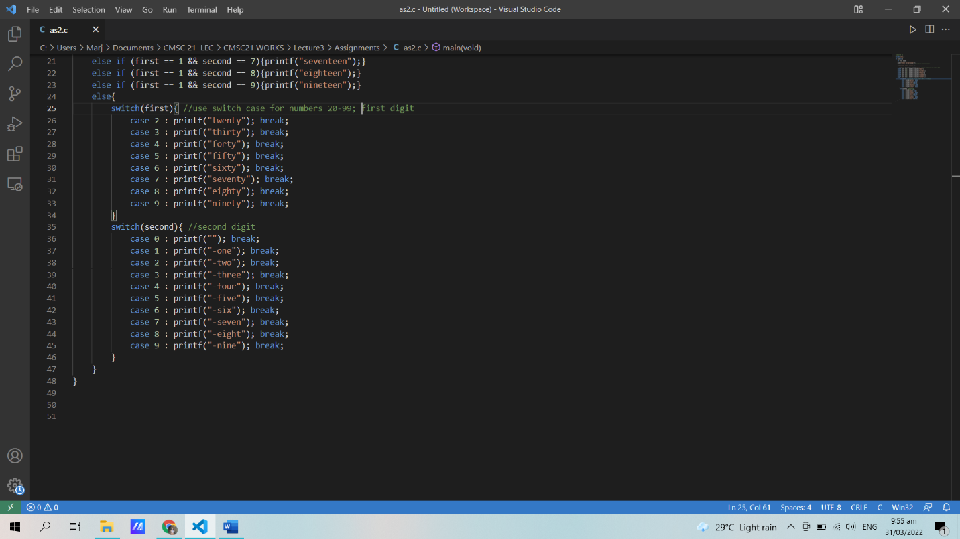

*Link: https://github.com/marj12/CMSC21/tree/main/Lecture3/Assignments*